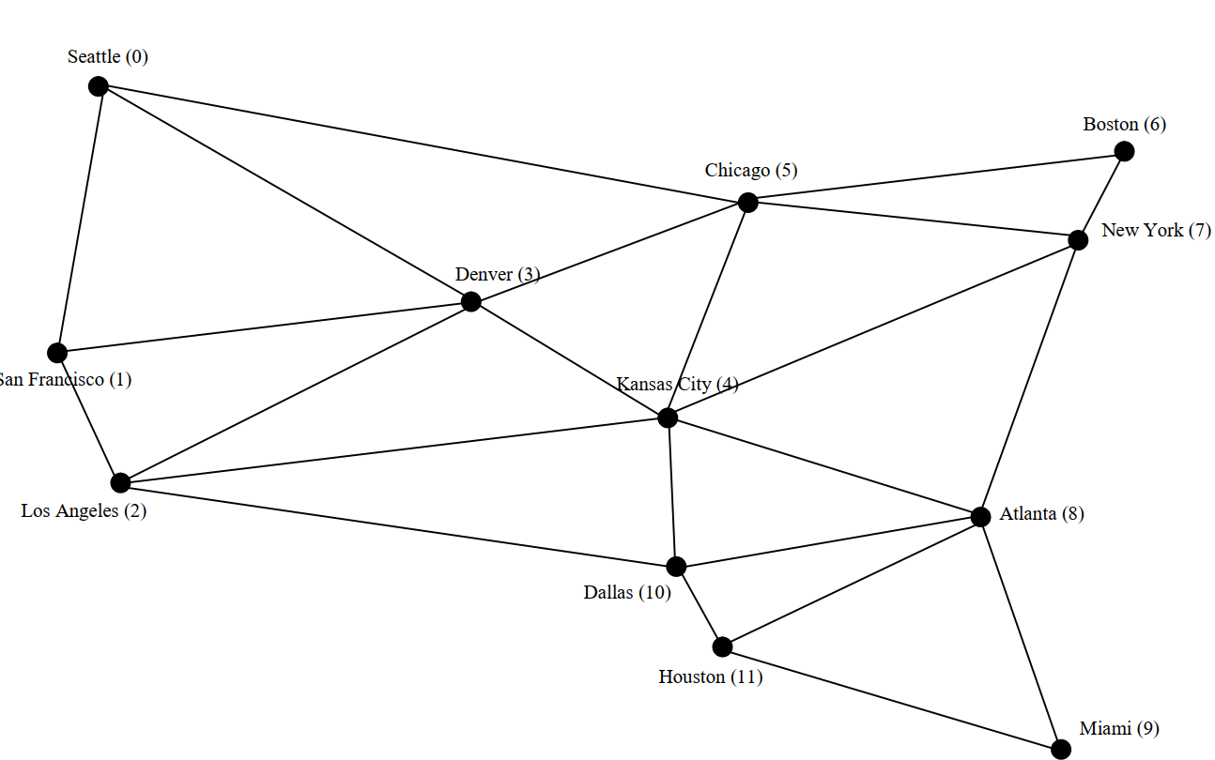
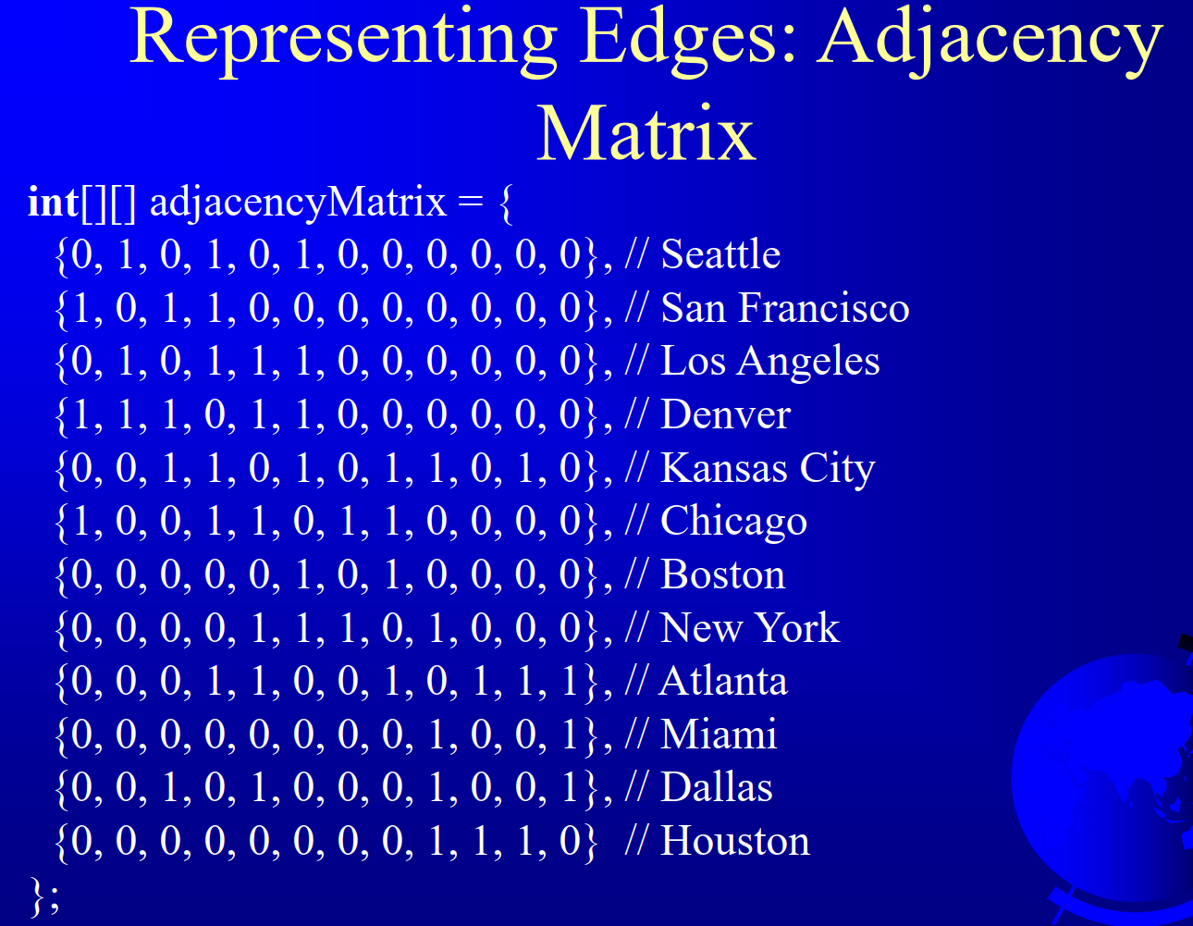
How does the “Adjacency Matrix” represent the graph above?
See my note for the answer.

